ZAPATILLAS MALLA
This free pattern originally published in the J&P Coats • Clark's O.N.T. Quick Crochet, Book 300, in 1953.
Buy the digitally restored eBook for $2.49.

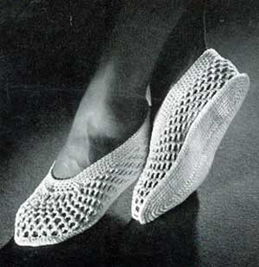
COATS and CLARK'S O.N.T. "Speed-Cro-Sheen" MERCERIZED COTTON, Art. C.44: 3 balls of No. 1 White.
Milwards Steel Crochet Hook No. 2/0.
GAUGE: 6 sc make 1 inch; 6 rows make 1 inch.
Directions are written for Small Size. Changes for Medium and Large Sizes are in parentheses.
SOLE . . . Work exactly as for No. S-434.
UPPER . . . Starting at back, ch 106 (122-146). Join with sl st. 1st rnd:Sc in same place as sl st, (ch 3, skip 3 ch, sc in next ch) 7 (9-12) times; (ch 3, skip 2 ch, sc in next ch) 6 times; (ch 3, skip 1 ch, sc in next ch) 5 times; (ch 3, skip 2 ch, sc in next ch) 6 times; (ch 3, skip 3 ch, sc in next ch) 7 (9-12) times, ending with ch 1, skip 3 ch, half dc in first sc. 2nd rnd: * Ch 3, sc in next loop. Repeat from * around, ending with ch 1, half dc in top of half dc. Repeat 2nd rnd until 5 rnds have been completed. 6th rnd: Place marker at center loop of toe. * Ch 2, sc in next loop. Repeat from * to within 8th loop of marker (not counting the center loop), (ch 1, dc in next loop) 15 times. Complete other side as before. 7th rnd: 3 sc in each ch-2 loop, sc in each ch-1 sp around. 8th and 9th rnds: Sc in each sc around, decreasing 3 sc evenly across toe— to dec 1 sc, work off 2 sc as 1 sc. 10th rnd: Sc in each sc around. Join and break off.
Sew 2 soles together. Sew upper to sole. Make another slipper the same way.

